Changing Clamp Levels SOP
- Connect Blue Chain to Blue hooks on both ends.
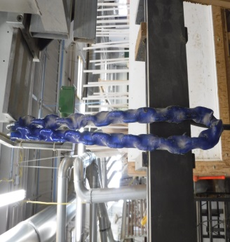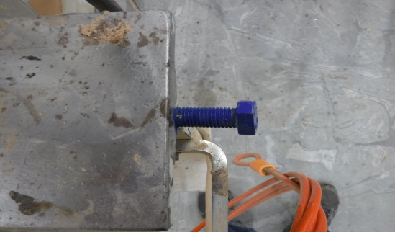
- Raise Clamp until lower level raises approximately 1 inch.
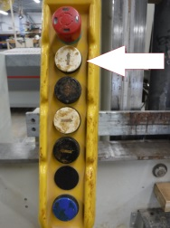
- Push & Hold Green button while lowering clamp, until clamp is lowered 2 inches, then the green button can be released.
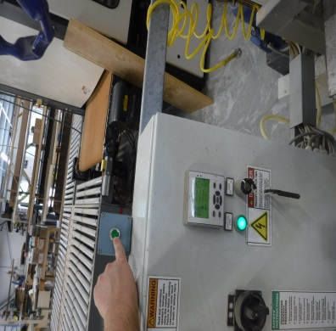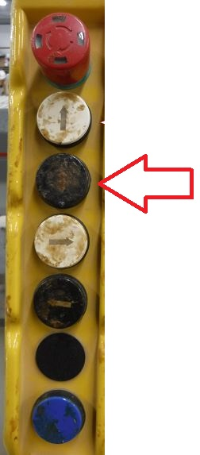
- Lower clamp until 1 inch after lower level stops moving.
- Disconnect Blue Chain on both ends.
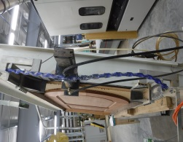
- Raise clamp to desired height.

