

Name: First Name Printed on Shirts? Yes No
Select 5 total mix or match (as needed)
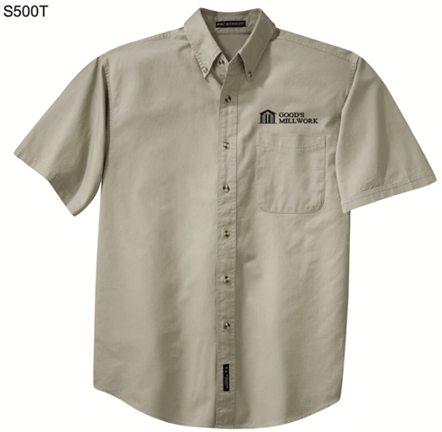  Color: Stone | 100% Cotton (5 oz)  (S500T) – Short Sleeve  Size_______ Qty_______  (TLS600T) Tall Long Sleeve, Size Large & Up  Size_______ Qty_______  55/45 Cotton Poly Blend(4.5oz)  (S608) – Long Sleeve  Size_______ Qty_______  (S508) – Short Sleeve  Size_______ Qty_______ | 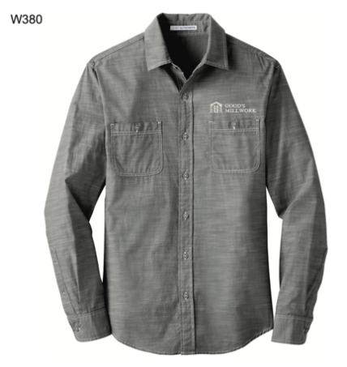  Color: Grey | 100% Cotton (3 oz)  (W380) – Long Sleeve,  Size_______ Qty_______  Sleeves shortened by  Elizabeth  Please leave as  long sleeves
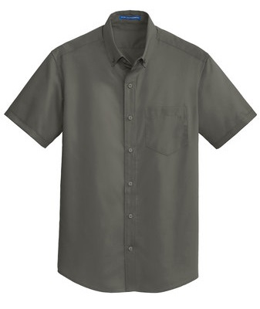  Color: Sterling Grey | 55/45 Cotton Poly Blend (3.4 oz)  (S664) – Short Sleeve  Size_______ Qty_______  (S663) – Long Sleeve  Size_______ Qty_______  Sizes – XS – 4XL
Jackets & Lightweight (approximately 1/year) No Name on Jacket (Logo Only)
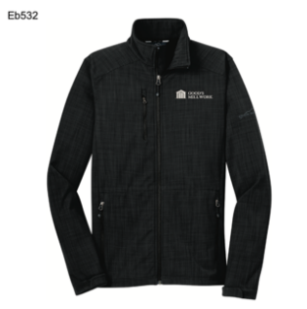  Soft Shell Jacket  Color:  Grey  (EB532) – Sizes – XS – 4XL  Size_______ Qty_______ | 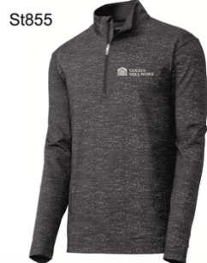  Color:  Charcoal Grey Heather  ST855  (ST855) – Sizes – XS – 4XL  Size_______ Qty_______ | 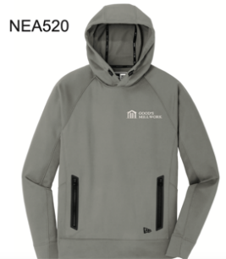  Color:  Shadow Grey  NEA520  (NEA520) – Sizes – XS – 4XL  Size_______ Qty_______ | 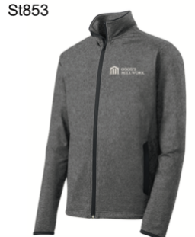  ST853  Color:  Charcoal  Grey  Heather  (ST853) – Sizes – XS – 4XL  Size_______ Qty_______

