
Good's Millwork Quote Request Form

Date: |  |  |  |  |  | Specie:
Customer Name: |  |  |  |  |  | Panel Profile:
Project Name: |  |  |  |  |  | Sticking Profile:
Phone #: |  |  |  |  |  | Hinge Color:
Sales Person: |  |  |  |  |  | Glass Pattern:
Qty | Door Style |  | Int/Ext | Size | Thickness | Jamb Size | Handing | Brick Mould? | Sill Type | Notes
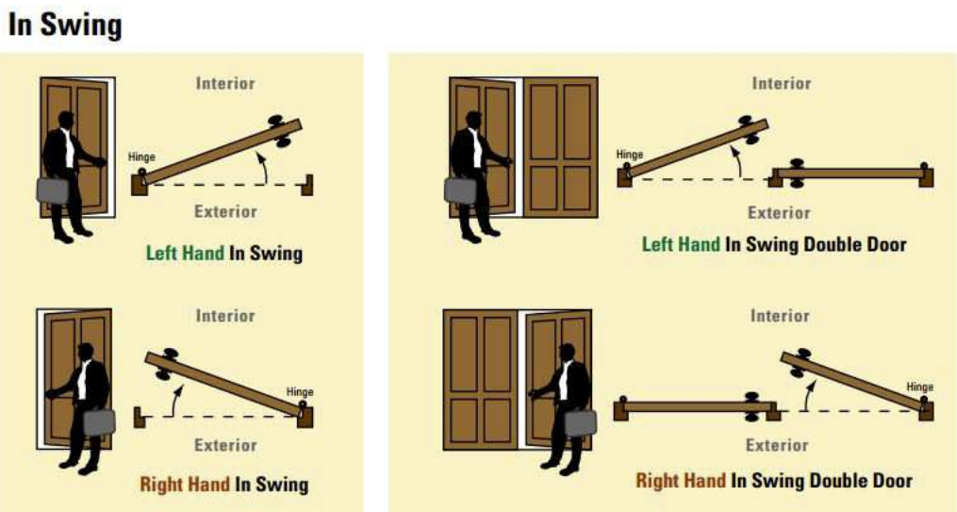
Please Note: Handing for doors is always determined from the outside.

